Practice 1 - Expressions and Functions

## Lab Assignment

**Instructions**: Test below commands in Python Shell.

[Hit Enter after each line. Observe what would Python print]

**Test 1: Print function**

>>> print (“Hello, world!”)

>>> print (“Hello” , “world! ”)

>>> print (3)

>>> print("2+3=", 2+3)

>>> print (“Hello, world!”)

>>> print (“Hello” , “world! ”)

>>> print (3)

>>> print(3.0)

>>> print (2 + 3)

>>> print(2.0 + 3.0)

>>> print (“2” + “3”)

>>> print (“2 + 3 =” , 2 + 3)

>>> print (2 * 3)

>>> print (2 ** 3)

>>> print (2 / 3)  
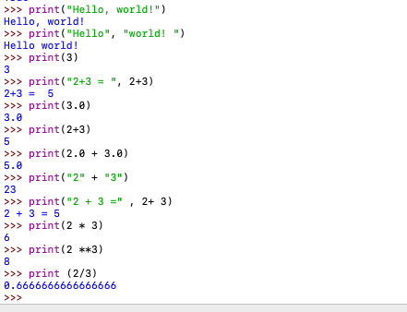

**Test 2: Arithmetic Expressions**

>>> 10 + 2

>>> 7 / 2

>>> 7 // 2

>>> 7 % 2 # 7 modulo 2, equivalent to the remainder of 7 // 2

>>> 6 + 2 * 5

>>> 4 ** 3 # Exponent

>>> x = 20

>>> x + 2

>>> x

>>> y = 5

>>> y += 3 # Equivalent to y = y + 3

>>> y * 2

>>> y //= 4 # Equivalent to y = y // 4

>>> y + x

>>> 3 + 4 ** 2

>>> a = 6 + 2 * 4

>>> a

>>> b = (2 + 2) * 2 + 3 % 2

>>> b

>>> a + 2 * b

>>> b += a # Equivalent to b = b + a

>>> a

>>> b

